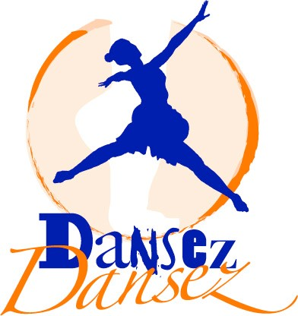

 

**An Unforgettable Experience!!!**

**RIGHT AT YOUR SCHOOL IN THE GYM!**

We offer **HIP HOP** classes at your school on **Mondays from 3:30pm-4:30pm.** Just come from your classroom to the gym and we will teach you the best, state of the art, funky, “à la mode” dance moves from the streets! High energy moves are key!

**WHO CAN ATTEND**

It is open to every grade level, all ages and dance levels.

# WHAT DOES IT COST

The first session will last for 8 weeks and will cost $184.

Checks are made payable directly to: Dansez! Dansez!

# WHEN DO WE MEET

September: 09/15, 09/22, 09/29

October: 10/06, 10/13, 10/20, 10/27

November: 11/03

**WHAT TO WEAR FOR CLASS**

Loose clothing, sweat pants, tennis shoes, anything comfortable.

# GENERAL INFORMATION

**Attendance:** we request that you arrive timely to your classes. Let us know when you are not going to be present via email: sabine@dansezdansez.com.

**Snow Days Policy**: We follow Montgomery County guidelines or Bells Mill Elementary School guidelines on snow and inclement weather.

**Code of Conduct**: We expect each student to respect instructors and other class participants. No “bully” attitude/behavior will be tolerated.

**Dansez! Dansez!**

Tel: (301) 652-2551

e-mail: sabine@dansezdansez.com www.dansezdansez.com

# WHO WE ARE

**Dansez! Dansez!** A multi-cultural dance school in the heart of Bethesda offering dance classes to all ages and levels. Conveniently located at 8020 Norfo4907 Rugby Ave, Bethesda, MD 20814, on street level, we offer classes in ballet, jazz, AfroCaribbean/Haitian folklore, hip-hop, Zumba, ballroom dancing, Latin dances, modern, creative movement, cardio dance and more. We have been teaching at several MCPS and private schools since 2006. We have also been teaching at several Montgomery County Recreational Parks since 2005.

# LIST OF CLIENTELE

YMCA, Bethesda, MD Herbert Hoover, Potomac, MD MCPS Back-to-School Annual Fair

Lycée Rochambeau, Bethesda, MD City of Rockville, Rockville, MD Maryvale Elementary, Rockville, MD

Bethesda Montessori, Bethesda, MD Glen Road Day School, Bethesda, MD Holton-Arms, Bethesda, MD

Burning Tree, Bethesda, MD Holy Redeemer, Kensington, MD Noyes Library, Kensington, MD

N. Bethesda, Bethesda, MD Girl Scout Brownies, Bethesda, MD Thomas Pyle, Bethesda, MD

Tilden, Bethesda, MD NIH Children’s Inn, Bethesda, MD Fallsmead Elementary, Potomac, MD

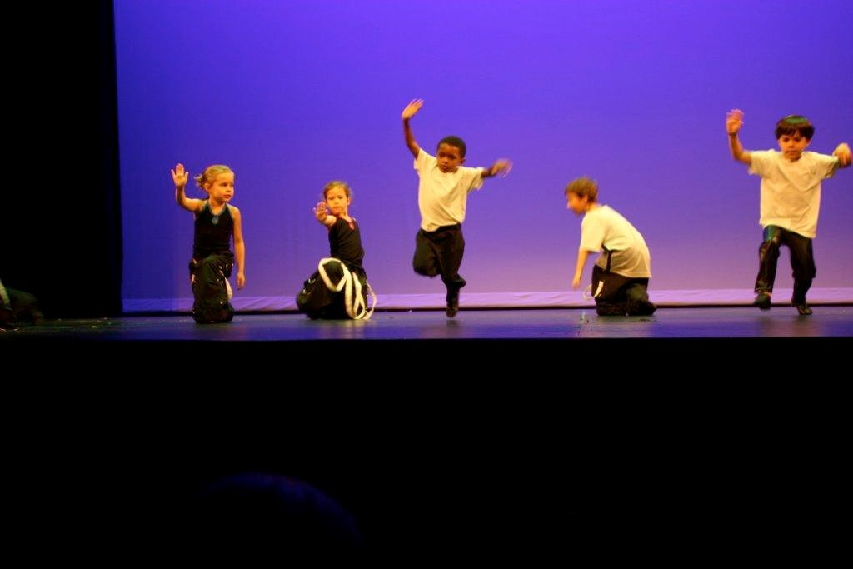

# REGISTRATION FORM

**Dansez! Dansez!**

Session 1 (8 weeks): Session Fee: $184

**Student’s Name: _________________________________ PM Teacher: _____________**

**Parent’s Name: _______________________________________________________________**

**Parent’s Contact Number: _____________________ E-mail: _________________________**

Please return to the PTA box in the Main Office by _____________, 2014.

For more information about this new, fun, after school program at Bells Mill, please contact: [klampasone@gmail.com](mailto:klampasone@gmail.com). Thanks.